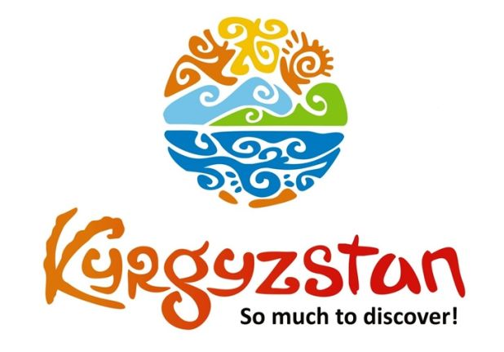**3 days tour around Issyk-Kul Lake**

Country: **Kyrgyzstan**

**Days: 3 / Nights: 2**

Organizing any complexity of tours to Issyk-Kul, Son-Kul, around Kyrgyzstan and Central Asia. We guarantee you high quality of service and individual approach!

During this tour you will travel to one of the most popular destinations in Kyrgyzstan - Issyk-Kul Lake.

Additionally, you will visit Burana Tower, Rukh-Ordo Cultural Center as well as Jeti-Oguz Valley and Skazka Canyon.

In these short 3 days you will be able to visit both Northern and Southern shores of Issyk-Kul lake.

#### [Day 1: Bishkek – Chon-Kemin (135 km/3 h)](https://concept.kg/en/tours/inbounds/55/#program_collapse_231)

#### 

In the morning meet a local guide/driver and depart to the Chon-Kemin Valley, a popular tourist destination for its beautiful virgin nature.  
On the way, visit Burana Tower, a small nearby Museum and open air Balbals (stone figures). The Museum collection contains such archeological findings as crockery, coins, sculptures, and other archaeological monuments.  
Upon arrival to the Kalmak-Ashuu village, check in at the Ashuu Eco Lodge. In the afternoon excursion to the Kalmak-Ashuu Gorge on a horse cart. Later, light trekking in the mountains and rest. Arrival to the guesthouse and some extra time for rest. Possibility to take a walking tour around the village, meet local people and explore the countryside.  
Available activities upon request (for additional fee):    
- Boorsok show (small pieces of dough fried in oil, Kyrgyz national bread);   
- Horseback riding

Meals: lunch, dinner

#### [Day 2: Chon-Kemin – Karakol (305 km/5 h)](https://concept.kg/en/tours/inbounds/55/#program_collapse_232)

#### 

After breakfast, leave towards the city of Karakol through the Issyk-Kul Lake’s Northern shore.  
On the way stop at the Tamchy village to visit local Kyrgyz family’s house to observe and participate in a Felt Craft Show. After the show, there is a homemade lunch with the family members.  
Visit the Open Air Petroglyphs Museum (stone inscriptions) and Rukh-Ordo Cultural Complex in Cholpon-Ata town.  
Upon arrival to Karakol town, check-in to a family run Kyrgyz-Japan Guesthouse (Sovetbek’s Guesthouse).  
Afternoon sightseeing tour of the old wooden Russian Church (built without nails), Dungan Mosque (Dungan’s are ethnic minority of Muslim Chinese, moved from the West of China) and Kupecheskiy Proezd street that resembles 19th century old Russian village. Further, visit one-village-one-product local shop for handmade souvenir products made by local women of the region. This shop is run by the association of local women who produce wide range of products starting from wild berry jams, handicrafts, herbal soaps and other souvenirs, all using products and materials found in the Issyk-Kul region.  
Dinner at a local café or at a guesthouse.  
Overnight at the guesthouse.

Meals: breakfast, lunch, dinner.

#### [Day 3: Karakol – Jeti-Oguz – Bishkek (430 km/6-7 h)](https://concept.kg/en/tours/inbounds/55/#program_collapse_233)

#### 

Early in the morning, it is possible to visit the famous animal market, which operates only on Sundays.  
After the breakfast leave Karakol and drive to the Jeti-Oguz Gorge. It is a lush valley with some striking red sandstone rock formations, including the “Seven Bulls” from which the valley takes its name.   
If the weather allows visitors can go to the famous Skazka (“Fairy Tale”) Canyon.   
The canyon was named after its bizarre rocky landscape, which for many years has been transformed by wind into various sculptures and formations. Some structures have been named for their similarity to the well-known objects and places. For example, one set of ridges in the canyon is called the "The Chinese Wall" due to its similarity to the Great Wall of China. Visitors can also find what appear to be the statues of hippopotamus, snakes, dragons, sleeping giants and even whole castles. Not only do the rocks have different shapes, but also various colors.  
Lunch on the way in the Bokonbaev village.   
Approximate arrival time to Bishkek after 17:00.

Meals: breakfast, lunch

| **GROUP SIZE** | **PRICE IN USD/PER PERSON** |
| --- | --- |
| 1 | 1115 USD |
| 2 | 760 USD |
| 3-4 | 675 USD |
| 5-6 | 580 USD |
| 7-8 | 540 USD |
| Supplementary for single accommodation | 150 USD |

| **TOUR PRICE INCLUDES** |  |
| --- | --- |
| Accommodation twin based | Chon-Kemin - guest house (1 o/n) Karakol - guest house (1 o/n) |
| Transport | Land transportation by air-conditioned non-smoking vehicle |
| Meals | Full Board: from lunch on Day-1 till lunch on Day-3 |
| Guide services (Eng/Russ) | Included |
| Entrance fees to museums | Included |
| Bottled water | 1 liter/person/day |

| **TOUR PRICE EXCLUDES** |  |
| --- | --- |
| Personal expenses | Not included |
| Boorsok show in Chon-Kemin | 80 USD for the show |
| Horseback riding in Chon-Kemin | 35 USD per person 50 USD for instructor (1 instructor up to 4 pax) |
| Felt show in Tamchy | 55 USD for the show |
| Folklore show in Karakol | 140 USD for the show |

**Contact information:**

[www.travelscruiser.com](http://www.travelscruiser.com)

Phone (24/7): +996 …………., +996 ……….

E-mail: [info@travelscruiser.com](mailto:info@travelscruiser.com)